**Pipe and Redirection Operations Assignments**

1. Create a script named “myscript” in current directory to do the following.

vi myscript.sh

a) create a dir named “subd1” in current directory

b) create a file named “dircontent” with contents of the current directory

c) display the contents of the file “dircontent”

d) display the contents of a non existing file named “unknownfile”

mkdir subd1

ls > dircontent

cat dircontent

cat unknownfile

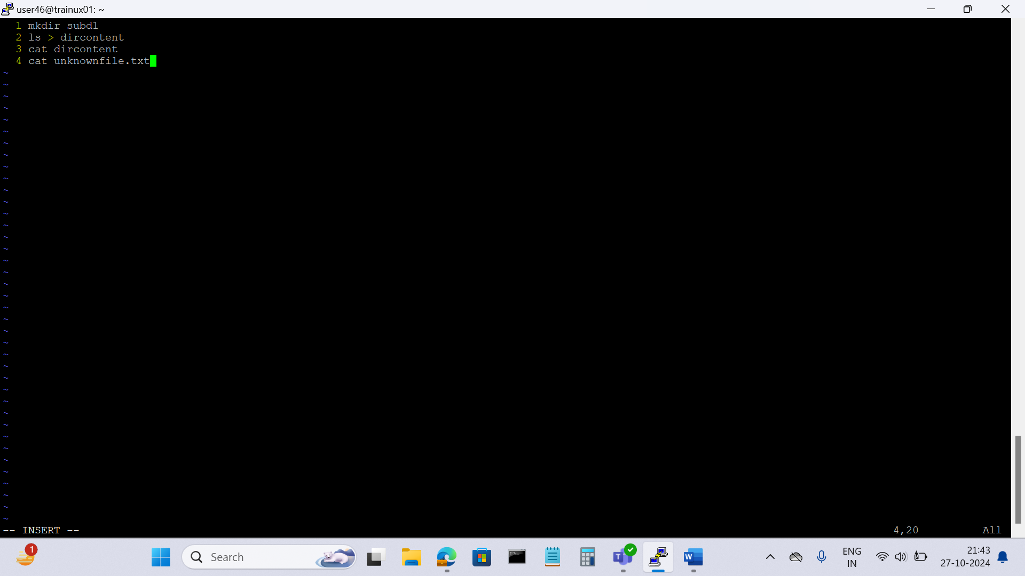

Before we run we need to make it executable file

2. Run the script and validate the output in following cases

a) Redirect only the stdout to an o/p file named stdout.txt:



b) Redirect only the stderr to an o/p file named stderr.txt



c) Redirect both stdout and stderr to an o/p file named stdall.txt



d) Display all o/p and error and also redirect both stdout and stderr to an o/p file named stdall.txt

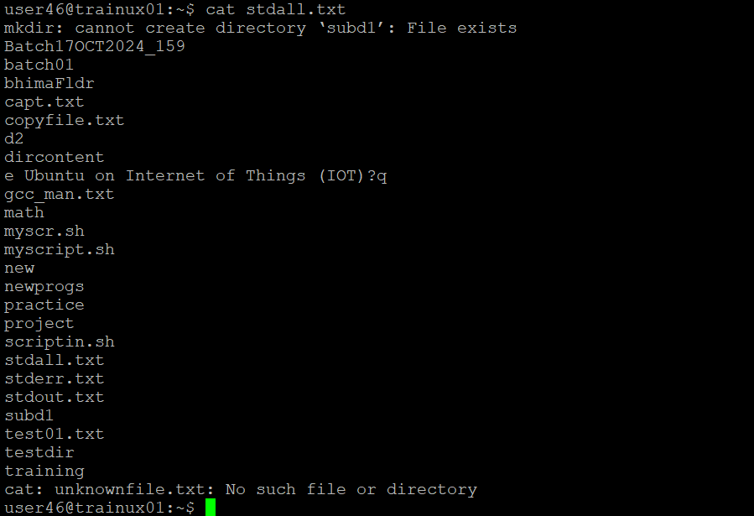

3. Redirect the output of command below using pipe (|) to wc and get the output .

ls -l : ls -l | wc

